ICT Project Guidance

Systems to Consider

Author:

Sky Sigal, Solution Architect

## Description

This document describes a number of system types to consider when planning the delivery of an information system.

## Synopsis

The delivery of an information service to meet service consumers expectations requires the identifying, planning, delivery, coordination and potential integration of a series of different systems: the Business Service itself, supported by a system to develop the information delivered within the business service, a system to package and deploy the business service.

## Contents

Description 1

Synopsis 1

Contents 2

Introduction 3

Background 3

Issue 3

Resolution 3

Systems 4

Delivered Services 5

Service Delivery Options 5

Avoidable Risks 6

Information Presentation System or Module 7

Information Creation System or Module 8

Information Management Service or Module 9

Integrated Capability Provision Services 9

Delivery Services 10

Communication and Virtual Meeting Service 10

Work Management Service 10

Documentation Management Service 10

Code Management Service 10

Compilation, Packaging and Deployment Pipeline Service 10

Appendices 12

Appendix A - Document Information 12

Images 12

Tables 12

References 12

Review Distribution 12

Audience 12

Structure 12

Diagrams 12

Terms 13

# Introduction

## Background

The terminology used when delivering systems leads to stakeholders concentrating on delivering the system that end users will be using.

## Issue

While delivering the system that users will use is important, concentrating the majority of delivery effort on it alone and omitting to plan for necessary supporting systems puts the service and project at risk in the near and long term.

Common omissions in planning and delivery include the management of resources that users come to the system for in the first place: the information within.

Other common omissions include the planning and delivery of a system to automate the quality assurance and deployment of both the above systems so that once ongoing deployments are rapid and do not introduce unnecessary risk.

## Resolution

Identifying a wider range of systems to consider and plan for -- or mitigate the absence of -- reduces risk to the project.

# Systems

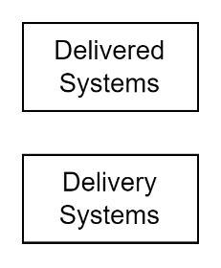

Figure : System Categories (HL)

The range of systems to consider can be categorised as either:

* **Systems delivered to end users:** whether they be external business service consumers or are internal business service provider users,
* **Systems used to deliver the above systems:** these are the internal business services used by Stakeholder Analysts to develop, curate and automate where possible the actions needed to maintain the service and its information over its full lifecycle.

Note:  
While it may seem obvious that systems are just the automation of repeatable human processes, it is common for ICT projects to miss the obviousness that project delivery processes can be automated as well.

The above two broad high-level categories can be categorised further.

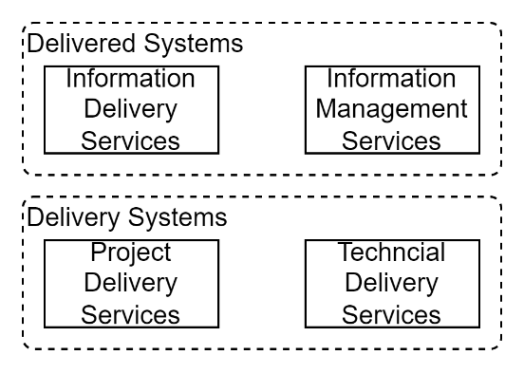

Figure : System Categories

The systems delivered to end users can be categorised further as:

* **Information Delivery Services**: the services used to deliver information to end users or integrated systems.
* **Information Management Services**: the services used to create, manage, and curate the information delivered via the *Information Delivery Services*.

Whereas the above services are the delivered services, the following are the delivery services:

* **Project Delivery Services**: the services used to collect, stakeholders desires, convert them to analysed and contractually acceptable definitions, before being handed over for technical development and implementation.
* **Technical Delivery Services**: the systems used by the delivery team to develop new systems, their packaging, deployment, configuration, and provisioning with information.

## Delivered Services

Most ICT services procured by business can be classified as “Information Management Services (IMS)”[1] or simply “Information Systems (IS)”[2]. Their primary function is to facilitate:

* creating information resources,
* collecting, maintaining, and curating them, for
* distribution, presumably helping users make informed decisions.

Consequently, such systems are expected to have the following capabilities:

* the ability to present information resources for user consumption,
* the ability to develop, maintain and improve this information, based on
* the ability to monitor usage and collect user feedback.

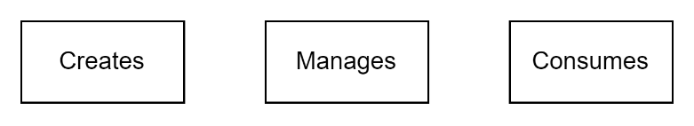

Figure : Primary Types of Information Users

## Service Delivery Options

Who creates, manages, and consumes the information depends on the business use case:

* *creation* of the information may be automated, using algorithms (e.g., Google summaries of public web resources, automated collection of monitored weather data, AI generated quiz and test items and answer options, etc.), by hired Subject Matter Experts (SMEs), by one type of service consumers producing for another type of service consumers (e.g., TradeMe, Amazon, etc.), or by every service consumer (e.g., Instagram),
* *management* and publishing the created information may be by the same group, or by a different group. For example, a business unit may be managing information they originally commissioned the creation of by external SMEs.
* *consumption* of the information may by a different group altogether (e.g.: the Ministry of Education publishes information for consumption by Teachers).

How these capabilities are delivered also may vary. They may all be offered by one system (e.g.: Instagram), one system having distinct modules (e.g., one area only accessible by vendors describing their services, the other accessible by their potential clients), or by multiple systems needing integration (e.g.: an internal system used to create and manage information that is later exported to a system used by end users).

The level of capabilities provided to manage the information resources created can also vary. From basic operations[3] with limited collaboration capabilities, to full lifecycle management operations[4], with the ability for multiple stakeholders to be involved using different roles.

## Avoidable Risks

While all the above listed options require discovery, discussion and decisions to prioritise the effort required to deliver them, the key avoidable risks are the omission of the planning required to:

* deliver the capabilities to create, maintain and curate the information presented to end users, so that it remains an asset and not become a liability.
* Put in place the processes and people to use the delivered information management service’s capabilities.

Important:  
while planning & providing just the basics to create, update, and delete information is less complex, therefore potentially less costly in the short term, it comes at an opportunity cost of the system missing capabilities to ensure the information remains an asset that increases in value, rather than becoming a liability that depreciates in value. This happens when the system does not provide the capabilities to collect user feedback to inform ongoing curation and improvement of the information provided and the underlying system that provides it.

## Information Presentation System or Module

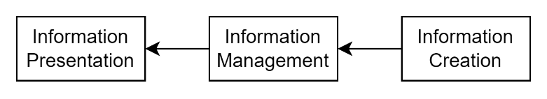

Figure : Information Presentation

Users use systems first and foremost because of the qualities[5] of the Information available within, supported in part by the experience accessing the resources, and not the technology used to deliver it.

Depending on the business use case the purpose and form of the information resources are myriad. Some systems are procured for displaying articles, while others are for providing information on services available, items for sale, quiz questions and possible answers.

The qualities of the information resources include:

* Meeting baseline ISO-25012 defined data qualities (Accuracy, Currency, etc.) with maybe special emphasis on:
* being developed in an appropriate manner (e.g., language, cultural references, target education level)
* being presented in a manner accessible to a wide audience, including visually impaired users (e.g., mindful font, font-size, colour, etc.)
* Being categorised appropriately for efficient and easy discovery.

The qualities of the system used to present the information are expected to include:

* baseline qualities as outlined in ISO-25010[6], with potential emphasis on
* the system being easily discoverable[7] and
* available to new users without complex or manual prerequisites
* able to meet expected peak demand

While most presentation systems provide the User Discovery services to determine what information to present to the users, some information presentation services use algorithms to select what information to present next to users.

For example, Facebook chooses the next advertisement to show a user based on what the user has visited or inquired about lately. An assessment service may choose which question to retrieve from an item bank (of questions and possible answers), based on the level of the learner, combined with what questions the learner has answered correctly or incorrectly in the past, etc.

### Information Creation System or Module

The information that is presented to users must be created first.

The information may be created algorithmically (e.g.: Google’s summary of publicly accessible websites, Facebook’s advertising), by end users themselves (e.g.: Instagram) or by service providers (e.g.: an organisation or government agency hiring SMEs to develop information resources for service consumers).

The creation of the data that is presented to end users may be done in the same system, or using another system, presumably one with more functionality.

If using a secondary system, the information must be transferred to the display service. This may be a manual or automated service.

A manual integration process might be one where the development of information to be shown in a website is done separately, using a Word document persisted in an online document management service and intended to be used by a web developer to manually update the website – the information presentation service.

A slightly more robust automated approach might be the use of an available JIRA service to develop custom forms to manage Items in an audited way and developing custom integration automation to publish information to a separate display service.

For a quiz/assessment system, the item bank of questions and possible answers might have been developed separately by contracted SMEs, and loaded into the system via a database.

More sophisticated would be the use of a 3rd party item bank development service, that exports the questions in a format that can be imported into the presentation system via APIs.

While technically more sophisticated, an approach that integrates two systems is usually marred by the integration being only one way, with collected user feedback not being sent back to the system where the information is developed.

### Information Management Service or Module

The information that is displayed to end users may be developed and managed in the same system that displays the information or be imported from another system.

Except for the simplest use cases, information requires being managed through many states. Mature organisations don’t just publish and update information when they feel like it -- they have processes in place to manage the delivery of new information.

New information resources are created by one and collaborated on by many team members, before being sent out for review by others, to be rejected or approved, released, and -- based on user feedback and usage metrics -- replaced with updated versions, sometimes merging with other information, before being removed reinstated, and provided feedback by end consumers.

This full lifecycle management of information capability can be delivered via a secondary system, or via a dedicated module within in the same service that is used to present information to end users.

If combined in one system, general user feedback and changes made by authorised users can be used to influence the ongoing improvement and culling of information.

If delivered by separate systems, planning is required to manage automated integration between the system that manages the information and the system that dispenses the information. Integration is needed to deploy new and replace existing information. When two-way integration is not provided, comments and end user feedback are lost.

### Integrated Capability Provision Services

The cost of procuring or developing new System capabilities is kept down by integrating with 3rd party service providers. Examples would be the use of Microsoft BI to provide analytics and reporting capabilities.

Note:   
It is important to note that when done naively, integrating with 3rd party analytics services (especially when providing custom report generation capabilities to end users) can introduce security risks.

## Delivery Services

The delivery of the above delivered services in turn relies on the procuring, configuring and integrating of delivery side services.

### Communication and Virtual Meeting Service

Teams use communications services to permit collaborating asynchronously on work items required to deliver outcomes.

Note:  
well known examples would include Microsoft Teams, Slack, etc.

### Work Management Service

Delivery team members manage business service development tasks, their prioritisation, and assignment using Work Management Service of some kind.

Before such services can be used, they require configuration to create a project specific workspace, reports and kanban board.

Note:  
well-known examples might include JIRA, GitLab, GitHub Boards, Azure DevOps Kanban and Work Item Management Service.

### Documentation Management Service

Projects develop discovery notes, requirement definitions, system designs amongst other digital documents.

A digital documentation management system is an appropriate place to store the information, with necessary access controls to limit access to project members, auditing their collaboration and access.

Note:  
well known examples might include the SharePoint aspect backing Teams.

### Code Management Service

The development of systems involves code that is stored in a code repository – a service that is separate from the above-described document management service.

### Compilation, Packaging and Deployment Pipeline Service

Code is compiled, packaged deployed to target infrastructure environments, quality tested and hydrated using automation.

The instructions to do this is referred to as a Pipeline, which is run on a Delivery automation service.

Appendices

Appendix A - Document Information

### Images

Figure 1: TODO Image 2

### Tables

Table 1: TODO Table 3

Table 2: TODO Table 2 3

### References

**There are no sources in the current document.**

### Review Distribution

The document was distributed for review as below:

|  |  |
| --- | --- |
| Identity | Notes |
|  |  |
|  |  |
|  |  |

### Audience

The document is technical in nature, but parts are expected to be read and/or validated by a non-technical audience.

### Structure

Where possible, the document structure is guided by either ISO-* standards or best practice.

### Diagrams

Diagrams are developed for a wide audience. Unless specifically for a technical audience, where the use of industry standard diagram types (Archimate, UML, C4), is appropriate, diagrams are developed as simple “box & line” monochrome diagrams.

### Terms

Refer to the project’s Glossary.

##### ISO-25012

: the internationally defined list of expected *Data* Qualities. The qualities are: *Accuracy, Completeness, Consistency, Credibility, Currentness*, dependent on the information’s *Accessibility, Compliance, Confidentiality, Efficiency, Precision, Traceability*, and *Understandability*, which in turn are dependent on the information’s *Availability, Portability, and Recoverability* qualities.

##### ISO-25010

: the internationally defined list of expected Qualities of a *System*. These qualities are expected of systems, within which data is managed. The full list of desirable system qualities are organised into the following category: *Functional Suitability, Performance Efficiency, Compatibility, Usability, Reliability, Security, Maintainability and Portability*.

1. [Management information system - Wikipedia](https://en.wikipedia.org/wiki/Management_information_system)
2. [Information system - Wikipedia](https://en.wikipedia.org/wiki/Information_system)
3. BREAD: basic Browse, Read, Edit, Add, Delete operations.
4. Create, Contribute, Review & Suggest, Reject, Approve, Describe & Calibrate, Publish, Endorse, Comment, Update, Replace, Merge, Remove, Restore.
5. Refer to ISO-25012 for Data Qualities to qualify data.
6. Consider referring to ISO-25010 System Qualities to qualify a system.
7. The service itself is referred to from the corporate website, and its publicly accessible content – information resources – are search engine optimised (SEO) for public web search engines (e.g., Google, etc.)